TTA Bargaining Survey Results
November-December 2025

The TTA Negotiations Team surveyed members between October 29th and December 9th to assist in developing the initial contract proposal to TUSD and driving bargaining priorities and principles. The initial proposal, commonly referred to as a “sunshine” proposal, will be presented to the TUSD Board of Education at their January 20th, 2026, meeting.
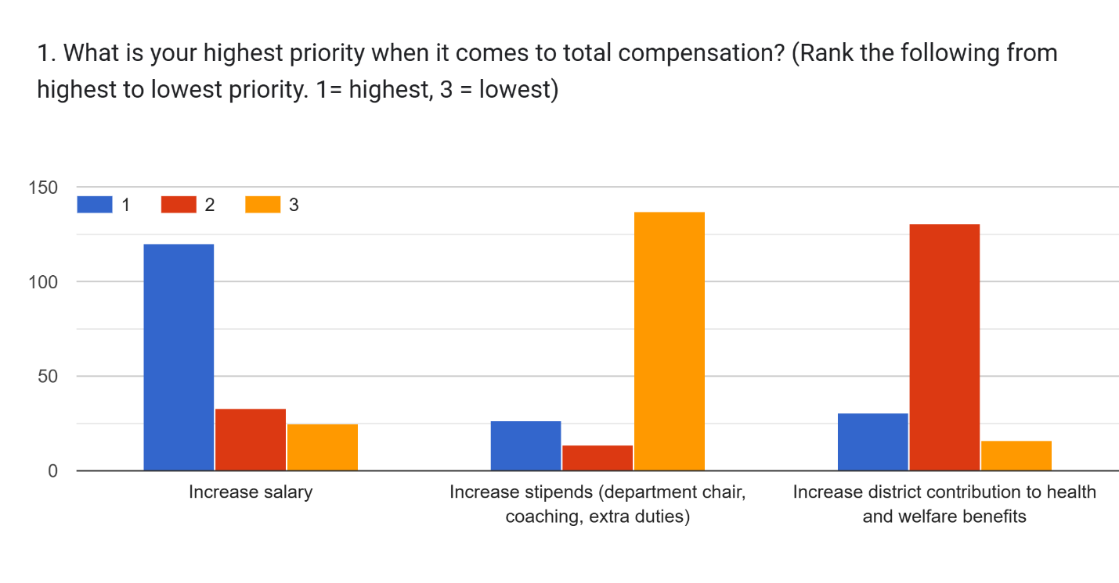
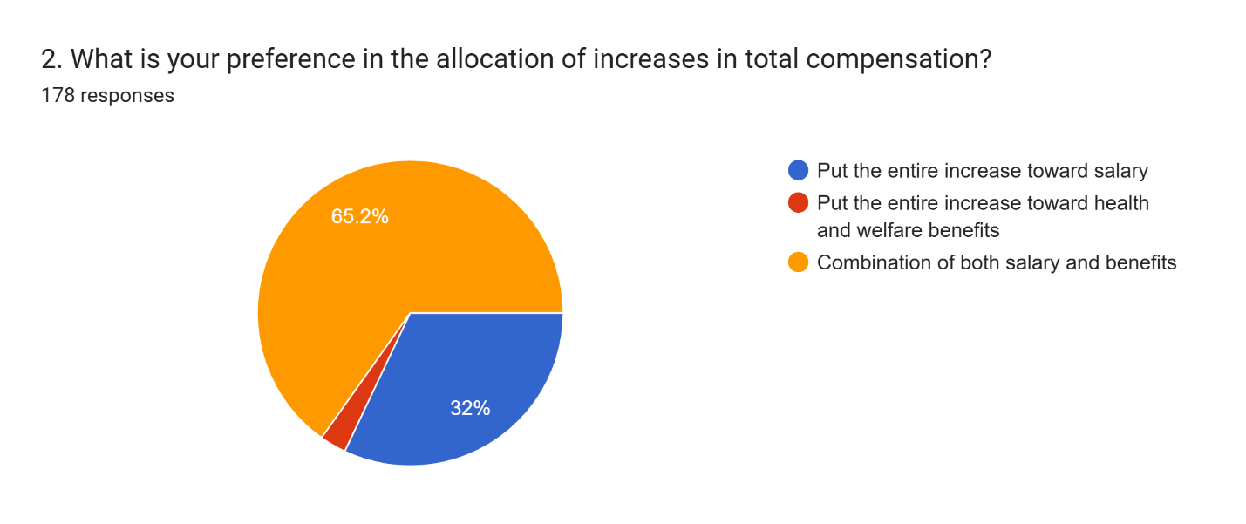
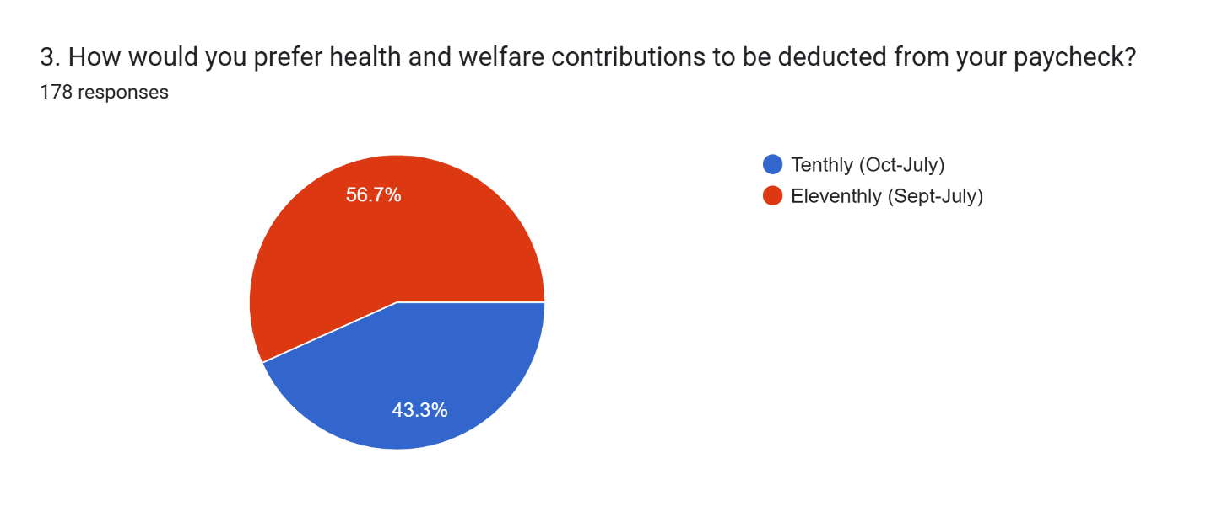
While it is unclear is we can move to an eleventhly model, TTA Negotiators and Insurance Advisory members plan to present the topic for exploration.

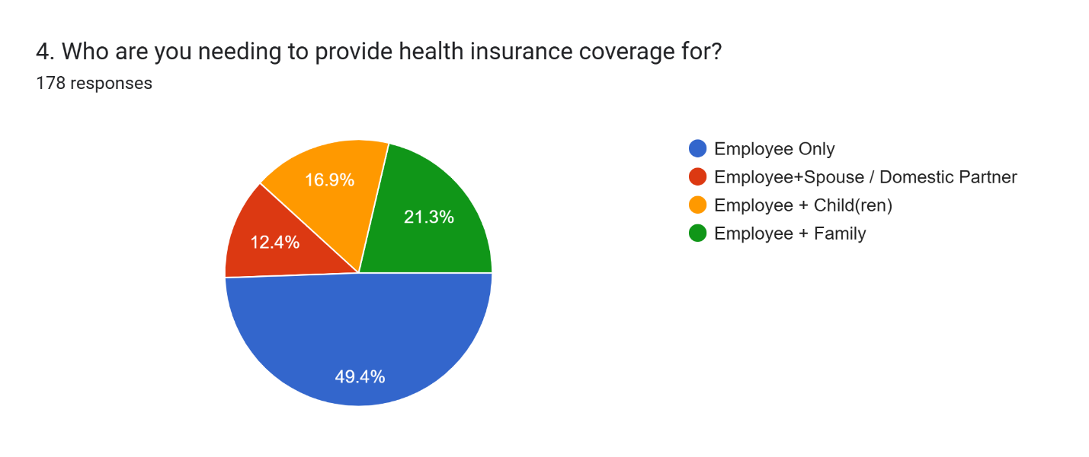
TTA plans to use this information to investigate more robust models of health coverage that add more young people to the plan pool.
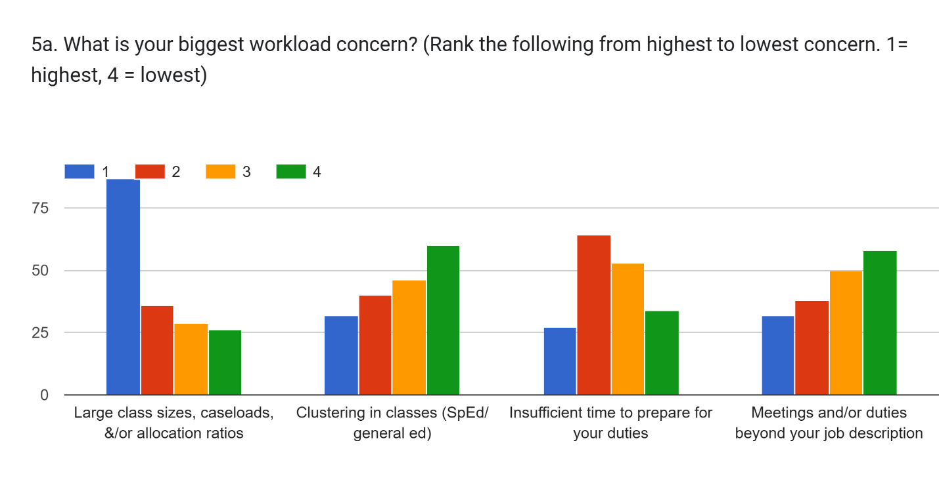
5b. Explain reasons for response in 5a.

I run the dance program at Torrance high and still am being forced to do adjunct duties even though other teachers in my department are not required to.

I am concerned that teachers and program specialists are managing caseloads that require more support than can reasonably be provided within the professional workday. The district has been very slow to fill vacant positions, some of which have remained open for nearly two years.

Hard to manage large caseload when I have to provide additional support elsewhere.

Asked by parents to provide handouts each day or compile a large folder of handouts for student absences in advance.

It’s never equitable. Some teachers get certain clusters because they r “goid” w those kids. Not fair.

I am a CTE teacher and have a lot more duties with my CTSO than most teachers. I work over 200 hours for the CTSO not including other class aspects over breaks, weekends, and holidays.

I find that student performance significantly increases with smaller, more focused classes
Low SPed scores are due to high number of students in a class

As a TK teacher I have a much better situation when it comes to class size and prep time. I made my selections from the point of view of a K-5 teacher based on my observations and conversations with other grade level teachers. For “duties beyond your job description” I read that to include not only excessive adjunct committees but also excessive data collecting and the time involved in gathering the data.

The SpEd students identified or unidentified are taking away from Gen Ed students learning in addition to a large class size so the Gen Ed students are not having their needs met because teacher attention goes to the SpEd students. At a small school, Gen Ed students never get a break from the screaming, crying, sometimes physical behaviors of the SpEd students because they will be together throughout their elementary education.

34-35 in each class makes everything more difficult.

Size is the common denominator of all 4.

We can’t be effective teachers with huge classes

Large class sizes are not productive.

Push in classes

Our workload keeps getting heavier without adequate support or compensation

Need training for push - in model

Every year students enter K from Launch needing paras but they do come with paras. We have to prove a para is needed in K. This makes for a very difficult transition.

All of the above are major concerns. As a 20 year veteran teacher, I am working harder now than I was when I started as a teacher because of the multiple job duties and responsibilities. Teachers are not supported. We are expected to do so much more, without time or compensation.

We don’t have rime in our contracted hours to plan and grade with genuine effort
Clustering of students is overwhelming in terms of workload and extra meetings/difficult parents.

The above doesn’t affect me too much

Multiply papers I grade for AP Lit. by how many students I have. I’m tired of sacrificing personal time just to keep up with my job.

There is hardly any time to prepare for the essential task because there are so many other meaningless duties.

I seem to be the only special ed teacher that sticks at our campus, and our site principal uses me as her basically on campus program specialist to where I’m attending more IEP meetings per week than she is granted I’m better at it than her, but I do have another job to do like my actual one

My only focus would be large class sizes, mainly due to the imbalance between other teachers (some with 36 some with 16). But that is a scheduling issue! As a dual teacher El Camino only takes 30 cap per English class due to the essay grading turnaround- here we have 36. It is simply fact that a smaller class receives a better education.

I love my job and literally dont care about any of those. Focus on salary

Larger class sizes with mix of SpED provides challenges that lower the quality of instruction for all students.

I see a clear improvement in learning with smaller, more focused classes

Clustering different levels of students makes it more difficult for lesson planning

Being the only full time Independent Study teacher, my work duties are different than the classroom teacher so not everything applies to my position.

I am a special ed teacher (only at my school) and caseloads are not doable with TK-5 and a caseload of 28 (or 25 which is news to me).

Constantly adding more, not taking anything off

Although I sometimes teach other teachers' students, I am not in a classroom, so class size and clustering affect me very little. But I am aware of and concerned for others on my site.

We have too many meetings at West, but that’s within our job description. The phrasing of the options doesn’t really reflect my concerns.

We all know we do work outside the classroom we don’t get paid for.

If class sizes are lower (should be 20-1 in primary) then everything else is more manageable.
Workload, especially with dual enrollment is not aligned to El Camino (I believe they cap their classes at 30).

Workload is increasing with EVERYTHING that we are asked to do and we at Elementary do not have planning time. I take a lot of work home because I am WITH students not prepping.
I’d like to make classes smaller and get rid of combos.

Increased caseload results in insufficient time to prepare for and attend IEP and Transition meetings. With a high caseload, we are missing therapy sessions to attend IEPs which in theory we are supposed to make up. The more students on caseload, the more IEPs we attend. Without time to provide make ups the students are the ones that lose out, and yet we are still responsible for their progress on IEP goals and objectives.

Class size is way to high for teachers to be able to manage so many issues with children today.
Not enough support for the amount to responsibility and workload needed to do my role effectively

Not enough time factored in for additional duties (IEP meetings, preparing IEP paperwork and report writing). No substitutes requiring compensatory therapy.

We are given more responsibilities, so most tasks are taking longer, and our caseloads are the same, so it is very difficult to manage and complete all the tasks within the legal parameters.
Caseloads have been way over for many years, and we are taking too much work home and having to cancel sessions for too many meetings and not enough time in the day, then we have to do makeups and it’s impossible to get it all done a smaller caseload that is actually adhered to would alleviate that and make for better outcomes for staff and students

Not in classroom

My classes are packed and sped kids need smaller class sizes so I can help them.
Clustering often upsets the balance in a classroom which may lead to increased challenges for productive instruction.

Well district has not provided any details or training for co-taught

As a learning center teacher, I am providing services and being a case manager. Not enough time to provide services, assess students, push in support, write reports and hold IEP meetings.
The workload is insane.

special ed is being degraded slowly at the detriment of students. The district admin is dictating who should get services and placement with no consideration for service provider's recommendations. As such, students who do not have any necessary skills to survive in gen ed are unilaterally being placed there to fail, and the directors blame it on "the state". They are failing these students.

There is never enough time to complete my work and yet each district adds more work to my plate and then makes me beg for more pay. I also teach AP classes, which adds so much work and stress to my job vs a regular teacher, yet I don’t get extra compensation for that.

Large class assignments make it more difficult to meet student needs.

#3 & #4 do not apply to my duties

Combo classes take a lot in preparation

Our special education inclusion model has significantly increased classroom teacher workload. Special education teachers are not collaborating on lesson planning, grading, or accommodations—responsibilities that fall entirely to classroom teachers. This arrangement limits special education teachers' effectiveness as true co-teachers; they function more as paraprofessionals despite their credentials and compensation. Additionally, special education teachers are frequently pulled from classrooms for behavior management and IEP meetings, further fragmenting their presence and support. Rather than addressing the root cause—inadequate staffing and role clarity—our school responded to compliance concerns by reducing the mandated support time in students' IEPs. This approach shifts the burden rather than solving the systemic issue.

Push in classes are a struggle for current teachers

SLP caseloads are MUCH higher in our district than recommended by CTA and a smaller class size would be much better for our teachers https://www.cta.org/our-advocacy/class-size-matters

Right now, my classes are at, or close to, the maximum allowed. Everything takes longer with bigger classes, so I feel rushed and less effective. I don’t make as close of a connection with my students when classes are large. I haven’t been hurt as much as some of my colleagues from SpEd inclusion, yet. I do feel pressed for time to complete my duties, especially the added time to post everything online and maintain my Schoology page.

Caseloads keep getting higher and more SpEd obligations constantly

Increased number of special ed students in my classes makes teaching very difficult. I do not feel qualified to teach classes that have this population and the number has increased to about a third of the students in each of my classes.

Too many meetings just for the sake of meeting.

Large class size is not ideal if possible.

SLPs need a lowered or weighted caseload. SLPs are not currently given time or enough for indirect required tasks including assessing, IEPs, SSTs, observations, etc. SLPs are required to cancel services to get all their responsibilities completed or have to stay for extended periods of time and then being told they need to make up those services. It’s impossible and adjustments need to be made in the contract to support better working conditions and workload
I don’t have a prep period. I also don’t have an area to spend my duty-free time.

The above question does not directly apply to me, but I tried to think in terms of my teaching experience.

Too many students, duties and not enough time

With SpEd clusters in regular classes and no para eds or SpEd teachers to help the regular classroom teacher, we can't manage it all in a class of 35 students.

It doesn't allow me to choose #2 for class size allocation. Not a huge issue for my department over the last couple years overall.

I noticed that at the middle school level if students are clustered - IEP/504, the only true difference between that model and having SAI classes was that special education staff were with the students in the general education classroom while the general education teacher was teaching but with an extremely limited ability to implement services and accommodations.
None of that is my priority. Salary and benefits

I do not have time in my day/schedule to complete all the things I need to do (e.g., plan, assess, write IEP's, paradigm, consult with others, etc.) since I have so many high needs students (being an SDC site

I am asked to do many things that seem to outside of my title as teacher and yet I am not given enough time to complete the tasks or assignments I am given.

I believe that if the district is truly concerned about K2 readers that they should lower class size so that we can actually be able to affect these children. Classes that are supposed to be capped at 27 but then go to 28 because the principal pressures the teachers to take 28 is simply not good for students is good for the teacher and it’s horrible in the long run.

Having SpEd cluster is hard on Everyone in the classroom!

Big class size means less one to one with students

27 and sometimes more students in the class is ridiculous. Impossible to meet all the needs of students.

We are tasked with things well beyond our job description.

Our district is an embarrassment and having to cover employee + family, I have been getting screwed for YEARS and lost our doctors and had to switch to Kaiser a dozen years ago when the kids were very young. I would strike TODAY and gladly sacrifice my pay to demonstrate that we are done getting screwed by the crooks at the top.

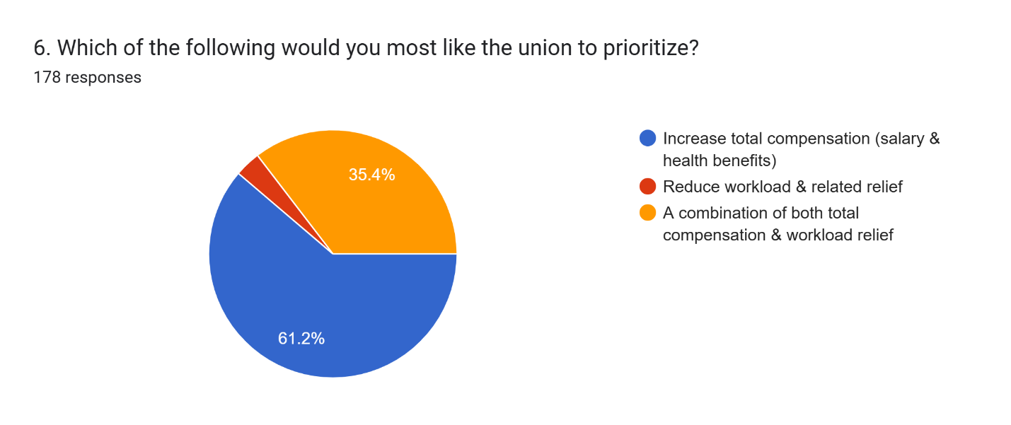

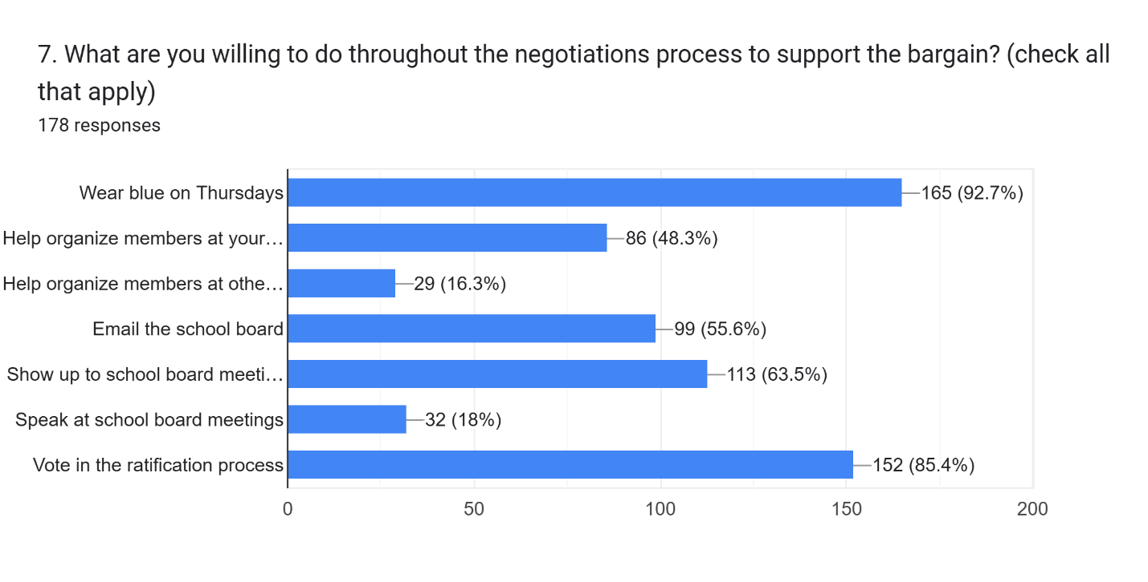
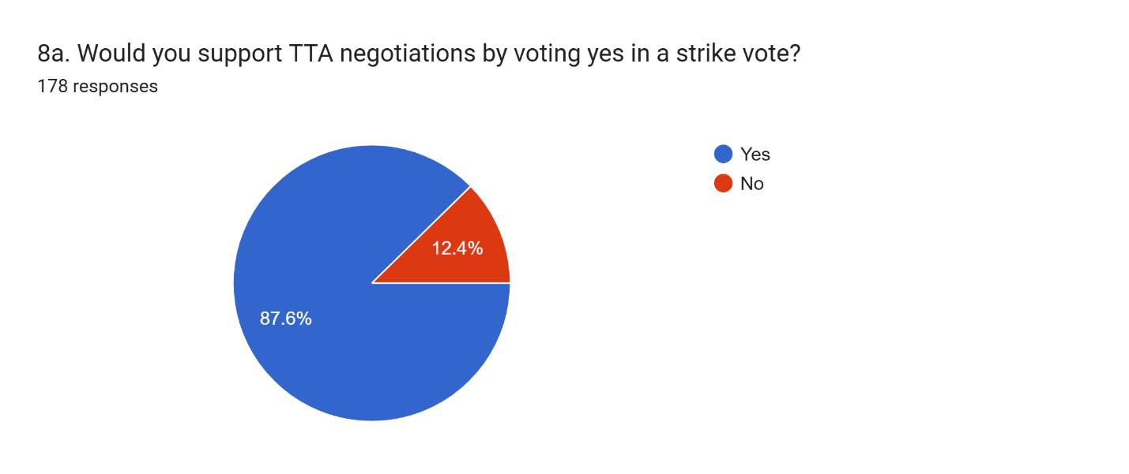
8b. Please explain our reason for choosing your response to 8a.

Honestly, I can because I have a spouse who has sufficient income to sustain them

If necessary, I would support a strike to promote transparency, build community understanding of educators’ needs, and advocate for a salary and benefits package that is commensurate with providing exceptional educational services. TUSD consistently ranks in the top 10% of public schools in California, and our compensation should reflect the high standards and dedication required to maintain that level of excellence.

It harms the students more than it helps me.

We all benefit from helping each other.

I feel like they continue to take advantage of us year after year, because they know they can. It’s time to show them no more!

The district (board and hire ups) do not listen and have an unfair compensation when compared to the work they do while standing in the back of teachers that do all the work and make them look good.

I appreciate the TTA's efforts and trust their negotiation recommendations

TUSD does not care about teachers. Something drastic needs to be done so they know we need to be supported and paid equally to other districts

I don’t know enough about penalties for employees if they strike. Do they lose sick days? Do they lose service credits and end up with an incomplete year of service credit? I think it could be effective to organize a flood of teachers taking sick days on the same days. One day, then another, then another, not consecutively. That’s a version of a strike that I would participate in.
Not sure if I would support it- depends on how many days.

At this point, the only real leverage we have to improve compensation is to strike. And the district knows it; they’re banking on us not being unified.

A strike is the last resort, but I support organized labor

I’m in year 25.

I will do what our union needs to do to get more $ that we deserve

We need the board we mean business.

I work hard and deserve more

Overall- I’d obv prefer to stay away from a strike. However- if the union feels that a significant difference would be made- ie: we know the budget is there and the district refuses to spend it in ways that teachers feel best represents them, and a strike would force the release of funds to support staff…. Then I would support a strike. Also. I have a hard time trusting the district and admin with the idea of improved workload- which is why I would push to support increase in salary/benefits. However, smaller class sizes or shared full time instructional aides are probably my top priority.

We need to send a message to the district that we are serious. They are banking on us never going on strike.

Need to do something effective

I do not want to strike, however, if that is necessary to make the changes, I will do what is needed.

Strong unions are good for everyone, and we need to remember our power

I am so fed up with everything.

If that’s what it takes to be heard, I am all in!

I’ve been teaching for 39 years. We need to do what’s necessary to get what we need.

I’m not sure if I would support a strike. I would need more info.

I think striking is great if it works for you but as a special education teacher, a sub can’t come in and do the job I do so when I come back, I’ll just have my workload plus whatever I missed while I was out on strike

I believe that a larger group has a larger impact- I would support my fellow teachers no matter if I agreed with the reason. Power in numbers!

We deserve equitable pay

I got a family to support

Will do whatever the group does.

I appreciate the TTA’s efforts and trust their recommendations

I’m not sure I exactly understand what a “strike vote” is and what all it entails.

I have tenure and would absolutely strike.

I can’t afford to at this time

I’m tired of seeing Tim Stowe get 5-6% raises when we get 1%

We need to stand together

We are worth more. We are always settling for less than we want. If TUSD can find funds to pay Tim Stowe over $330,000/year, when a district like LBUSD pays their sup only a bit more ($371k) with over twice the number of schools (31 vs. 85), they can find the funds to compensate faculty and staff at a competitive rate. We can do better.

My workload has become unsustainable, and my salary is not able to support the cost of living. I was raised in a union family and understood the need to strike when necessary
While I would support it, it will never happen. People don’t even bother to vote.
Because it will force the district’s hand, and surrounding districts make more $. If we are considered a good (great school/district) then we deserve credit/compensation.

If it’s determined a strike is the only way to be heard, then I support that.

It’s become painfully clear that without meaningful action, we will continue to be undervalued and underpaid. The district knows we won’t strike, and they count on that, which is why we are always offered the bare minimum while our leadership continues to receive raises. If we don’t show that we are serious, nothing will change. We can’t keep settling. We deserve better, and it’s time we act like it.

I believe that supporting a strike shows the Board how strongly we feel about our current contract.

We ask, we negotiate, we make compromise. As a result, we seem to keep losing the battle in simply receiving what is just and fair. Our profession is being attacked at federal level and not supported at state or local— despite what all the politicians like to spout from their soap box. So yes, some backbone to our grievances might be the actual option to bring about significant change.

Yes, but I am very hesitant to do so. If done right, bringing attention to what we do and the lack of respect, understanding and compensation that the community just doesn’t realize.

We need to show a true threat to the district so we can put some power back into the teachers’ hands.

The School Board and administration are counting on TTA membership to accept an unfair contract. We shouldn't accept an unfair contract and just roll over.

To many variables for it to not work

I think a strike is a nuclear action that should be reserved for extreme circumstances.
If we are that deadlocked, then yes something has got to give but it would have to be pretty bad to actually strike

Insufficient pay and poor health care coverage have gone on too long.

District needs to know we mean business. People must be willing to strike to push the district to understand the distress teachers are in.

Yes BUT, only if the staff is turning things up

I will vote yes, but I can’t say confidently that I would strike if it were to come to fruition.
Striking demonstrates my sincerity to be treated as a valuable member of the TUSD community. Striking would increase the awareness that teachers are not compensated fairly in relation to the administration.

Strike is not warranted at this time

I’ve been with LAUSD and we went on strike it seemed every other year and always won for what we fought for

If it comes to that, I will support a strike. Hopefully will not be necessary. Thank you to all the TTA team for your continuous efforts!!

Yes, however a long strike would extremely negatively financially.

A strike is one of the most powerful tools a union has to put pressure on the district to give into our demands. At this point I feel like it is the only thing that will work, because clearly they have shown they don’t care about the workers or value are work, but they will have to give in if there is nobody to teach the kids. Using the students and parents as leverage will get them to buckle. I’m fed up and I know there is corruption going on, I just don’t know how we can prove it. I honestly don’t know how they look at themselves in the mirror.

I would vote for it, but the salary loss scares the heck out of me.

Even though we would take a hit, typically a strike by teachers doesn’t last long due to community pressure. I think the hit in pay on potentially one paycheck is worth letting the district know we are serious and not willing to back down for what we deserve. If the district knows we are willing to strike it could help with potential future negotiations by putting us in the seat with “power”.

Our district faces systemic inequities that demand action: Compensation crisis: Our salaries rank lowest among comparable districts, and fringe benefits are equally inadequate. Misaligned priorities: TUSD awarded raises to superintendent and cabinet staff while cutting teacher pay—a clear signal of misplaced values. In addition to creating extra positions that are not needed. Pattern of bad faith: The district has consistently acted without genuine regard for educator concerns, including documented retaliation against those who speak up. Negligence and disrespect: After working across multiple districts nationwide, I've never experienced this level of condescending treatment and institutional neglect. Our students deserve teachers who are valued, fairly compensated, and treated with dignity. We cannot provide our best work in an environment that actively undermines our professional worth. It's time to make clear: enough is enough. I'm ready to stand with my colleagues and hold TUSD accountable.

We currently have no power with the district, ready to show our strength to try to balance the power dynamic

Conditions are not bad enough to strike at this time

Striking seems very extreme

While I hope things would never come to a strike, I trust my union and believe in organized labor.

I feel like that might be the only way we are taken seriously. This has gone on too long.

It has been a long time coming. I support a strike. We need to be taken seriously.

I would support TTA but am scared to strike as im the only income for my family.

I cannot live another year with these high health insurance costs. We are scraping by. I like working here a lot but logically can’t stay with this financial burden.

I am not sure; it would need to be very serious for me to strike.

Fair compensation with other districts.

If a strong message is required, I’m willing to step to the plate. Honestly, I don’t believe MOST teachers at my site are willing to take the same action, (hopefully I’m wrong).

I would go with what the majority would do

I support the union and whatever they think is necessary

If absolutely necessary, I would vote that I was prepared to strike in advance of negotiations to emphasize the dedication to our proposals.

We absolutely should strike. Why wouldn't we? The district will face overwhelming criticism, exposure and pressure from the public. We will NEVER be treated fairly or with respect until we stand up to the bully. The district will be SHOCKED because we will have finally found our cahonas. (or however you spell it.)

I am willing and ready to strike

If we continue to earn less money than we have in previous years, while cabinet members make very high salaries, we need to strike

There is power in numbers!!! We ALL have to make a stand or it just won’t work!!! We have to be UNITED & STRONG to send a message and make a change!!!!

It’s time we pressure members who do nothing. If we fail at impasse. Strike! They don’t think we have the stones. And they’ve been right for too long

I stand with TTA. Thank you for everything.
Whatever it takes

strength in numbers

After over 25 years in the District, I have seen the level of respect and compensation for my job decrease while the District administration gets more and more despite being the farthest from the classroom. Having direct contact with students and families on a daily basis seems to be the most important and yet is compensated the least for our years of experience and levels of education.

Is a strike vote where we end up going on strike? I don’t think going on strike is a good idea since I am the sole breadwinner in my family.

Currently I do not feel That things are bad enough for a strike

We are willing to take lower benefits compared to other districts as long as our salary is in the top two. Example is hacienda. The other thing I want to mention is that the reason other sites are always “happy” with what is negotiated and that is because they are not well informed and not involved. The sites that are most invested are the ones that are not pleased with always taking raises that keep us at the bottom.
.
It’s the only way the district will feel the impact

We would probably asked to sub if this happen

